**

**Blockit Scheduling Queue Instructions**

**To schedule an Orthopedic Referral for patients discharged from the ER to home, follow the user instructions below.**

❶ Login to the Blockit application using your **email address** and the **password** that you created. (URL: <https://app.blockitnow.com/login>) or use the **SSO toolbar** button to login automatically.



❷ The patient is discharged from the ER to home by the provider with an Orthopedic Follow-Up Referral. Navigate to the **Workflow Queues** tab on the blue ribbon bar.

z

From the *Scheduling Queue,* locate the patient which will be scheduled for an Orthopedic referral and select **Schedule**. Referral details are available within the *Details* button.

 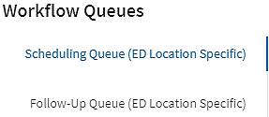

❸ The *Search* page will appear with the referred to provider group schedule. If the patient confirms they are ready to schedule, select their preferred date and time by clicking the **desired date / time** black box. See step 7 if the patient is not ready to schedule their appointment. The distance from the patient to the provider is available, along with an Insurance Match, as available. 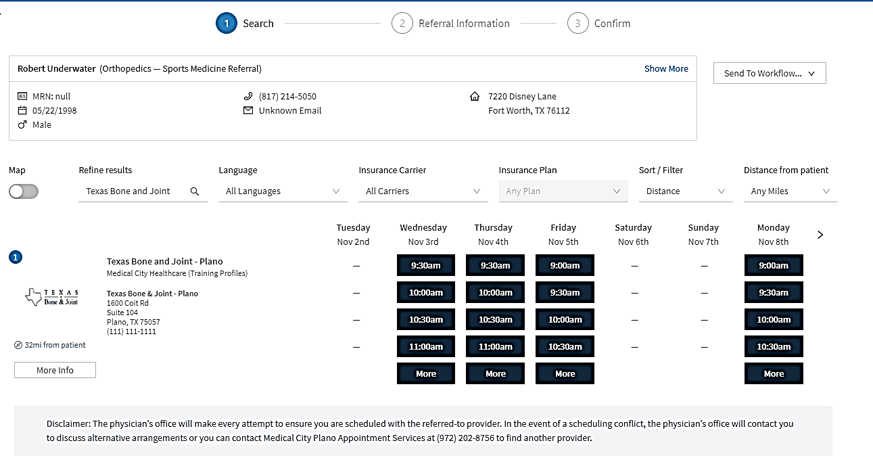

**

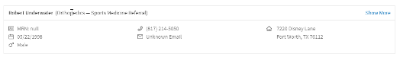❹ The *Referral Information* page will display to request the details from the provider order. Documents and the Diagnosis (ICD-10 code) can be included but are not required. Notes should always be included to indicate the referral reason(i.e., left foot & ankle fracture, right hip fracture, etc.). **Disclaimer must be read to patient and acknowledged.**

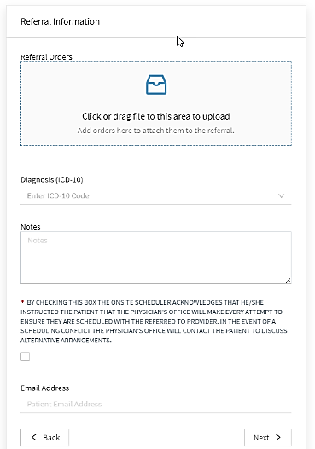

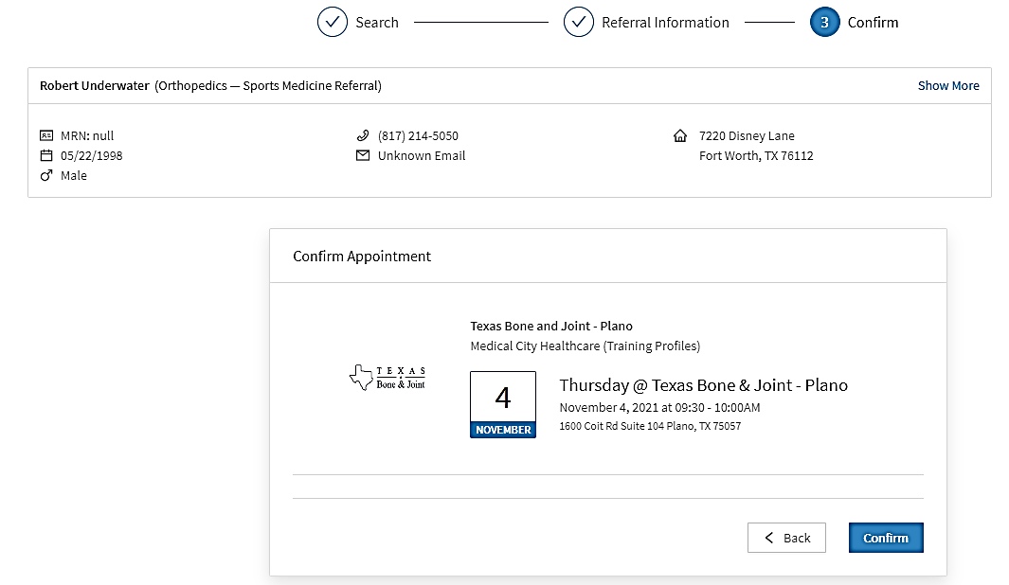

❺ When the *Referral Information* is completed, select the **Next** button to move to the *Confirm* page for final confirmation.

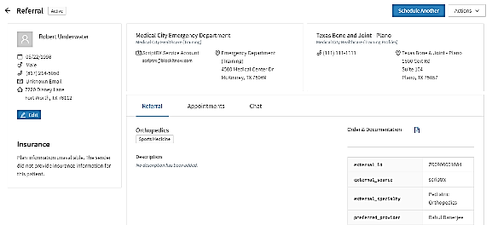❻ A message will display at the top of the page confirming a successful booking of the referral and a final screen with the patient referral details will be available. **Note:** You should be sure to write down the appointment information on discharge paperwork for a patient reminder.

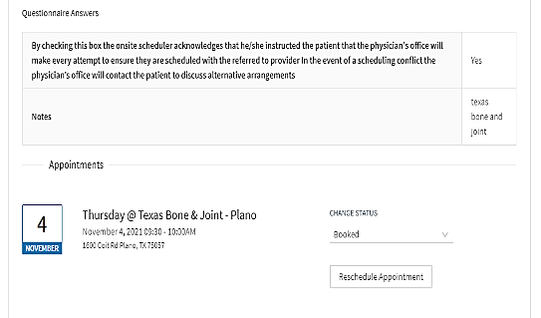

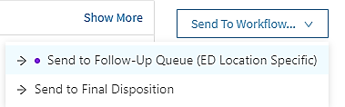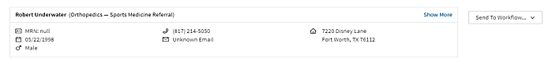❼ If the patient is not ready to schedule their referral, hover over **Send To Workflow** on the top right-hand side of the *Search* page (step 3), then select **Send to Follow-Up Queue**. Type in the reason for visit (such as finger fracture) and select the appropriate reason for sending to the follow-up queue in the pop-up box and click OK. These patients will receive a follow-up call the next day to assist with the appointment scheduling.

07.13.2022