For ED Only:

Documentation of Neuro Checks will be done as NIH only. For Alteplase patients ED will document on the paper form. Once transferred to ICU or IMCU documentation will then be done in **MEDITECH ONLY** for duration of monitoring.

**How to locate Frequent Neuro Checks**

Click on Process Intervention:

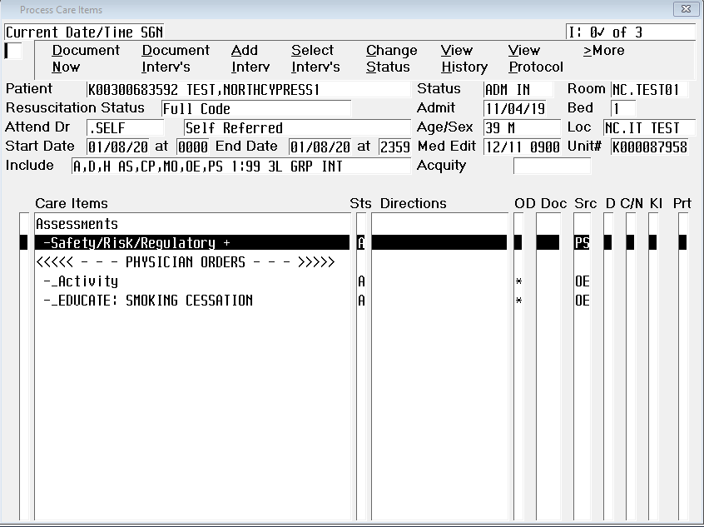

Then Add Intervention

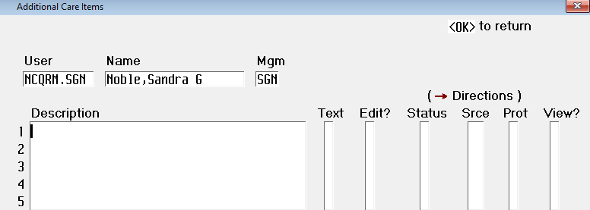

Click inside Description, use F9 key and scroll to Frequent Neuro Checks

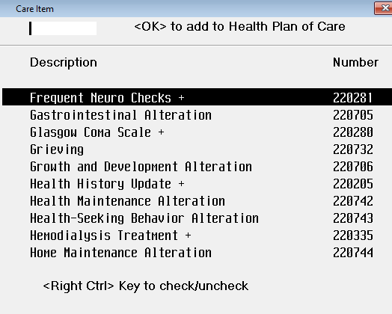

Frequent Neuro checks are to be done every 4 hours until otherwise ordered by physician