**Click the Orders button (Use Z order source, as the protocol is already ordered):**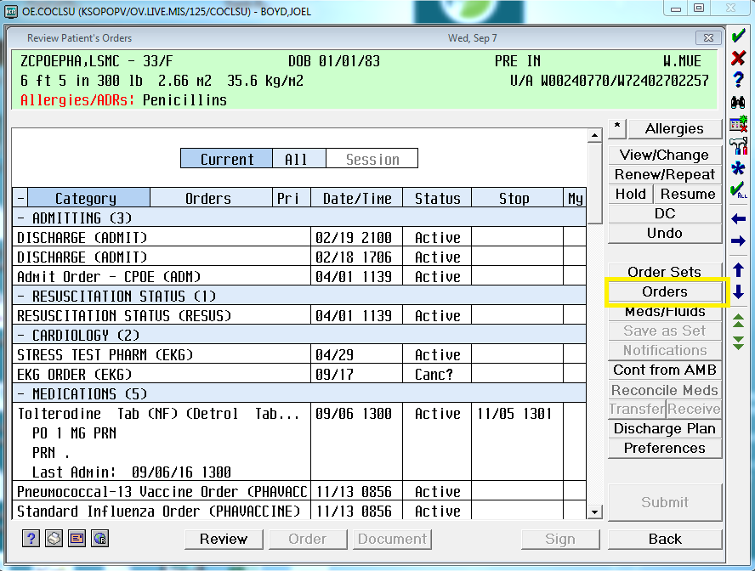

**Search for “K MAG” under orders:**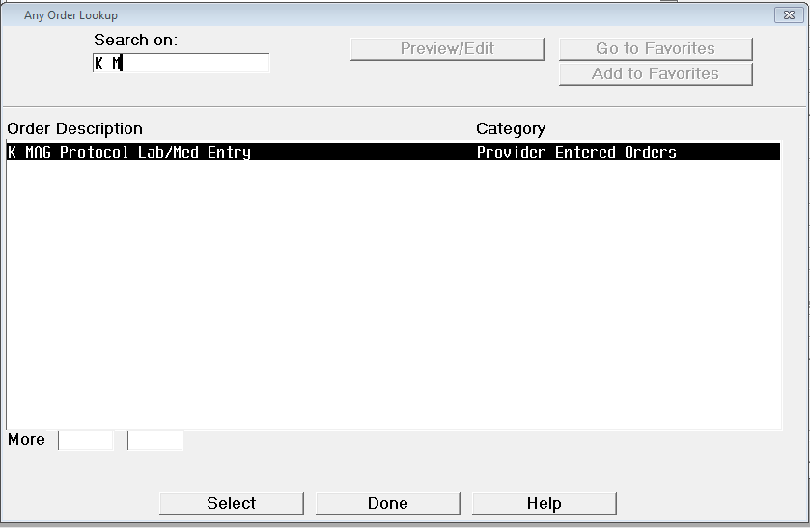

**Input Mag level (most recent result will pull in):**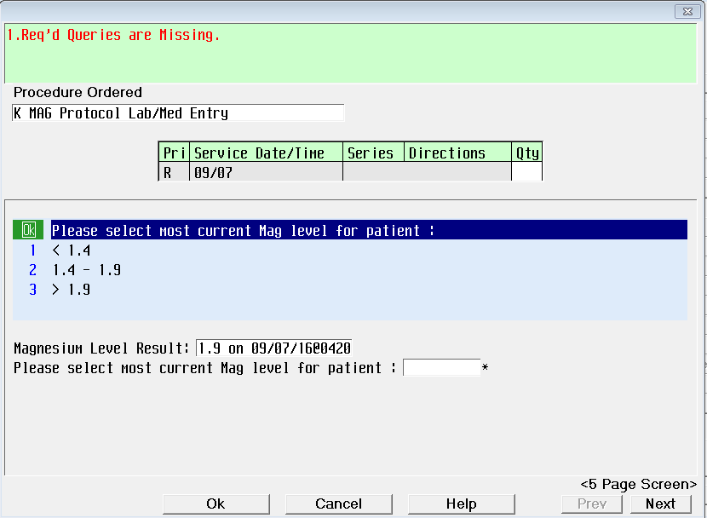

**Input K level (most recent result will pull in):**

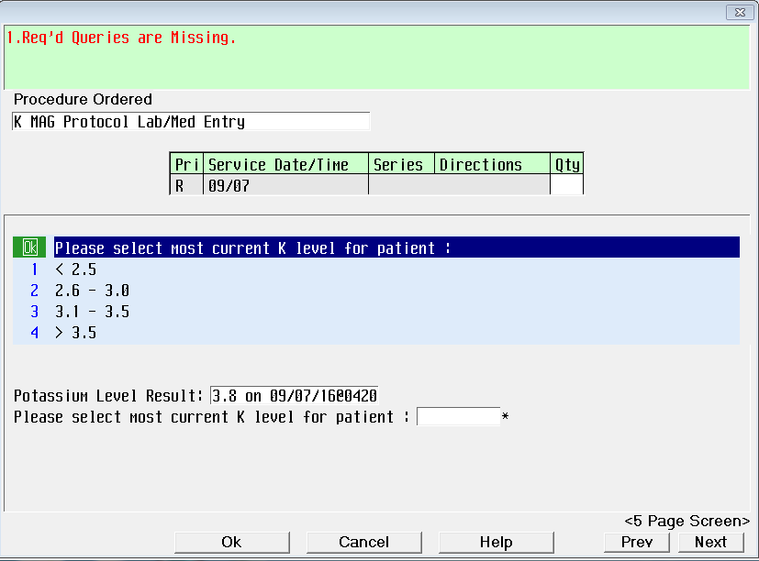

**Input oral intake status (note comments on order):**

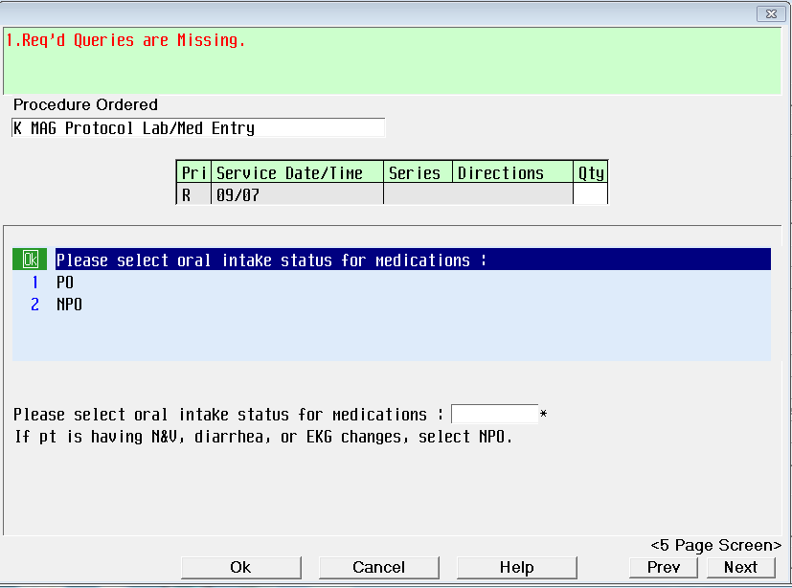

**Input IV access:**

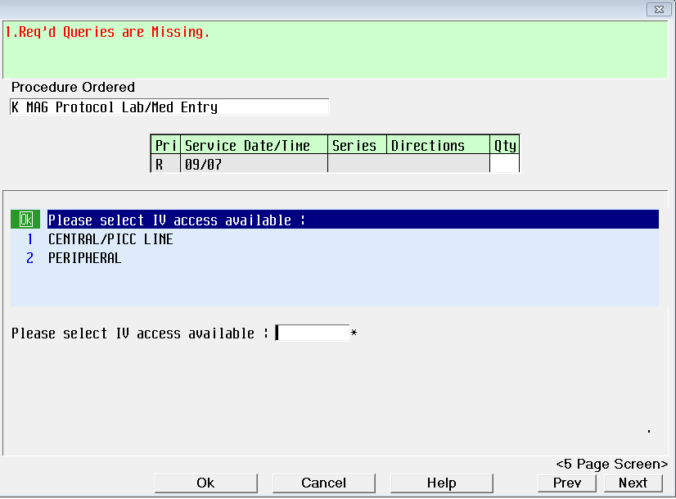

**Medication and Lab orders will reflex pretimed, click through required queries in red:**

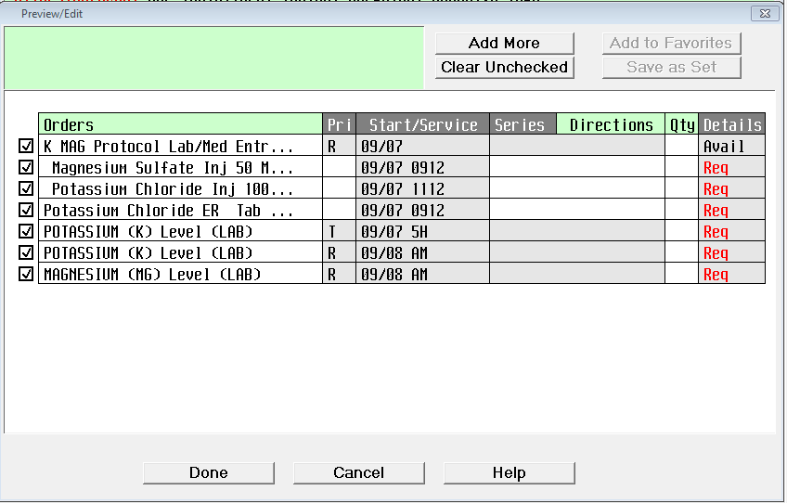

**Ensure to place order again if potassium replacement is needed after the re-check.**