

**Order Acknowledgment Reinstatement**

Go live: XXXX XX, 2022

**EHR**

**Update**

**Points of Emphasis:**

**Acknowledgement of orders** indicates that staff **reviewed the new orders** and must be completed as soon as possible. It does not translate to completion of order.

**Procedural orders** such as Preop and PACU’s are **acknowledged by the procedure nurses**.

Order Acknowledgment **does NOT replace chart check process**.

**Medications** can be **acknowledged** on **EMAR or the status board**.

**“Ack” vs “New” Flags**

**MEDITECH ORDER FLAG HIERARCHY (in order from highest to lowest priority):**

* **Stat:** STAT order not yet acknowledged/reviewed by current user. (**Highest Priority**)
* **Unv:** Unverified order occurs with orders with missing information (seldom seen).
* **Xfer:** Transfer order
* **Ack:** New order that needs reviewed and acknowledge
* **New:** orders not yet viewed by current user (**Lowest Priority**)

1. **Ack flag:** New orders that needs to be reviewed and acknowledged.
2. **New flag:** The system recognizes which users have viewed the orders so the “New” flag will display until the nurse views the new orders.

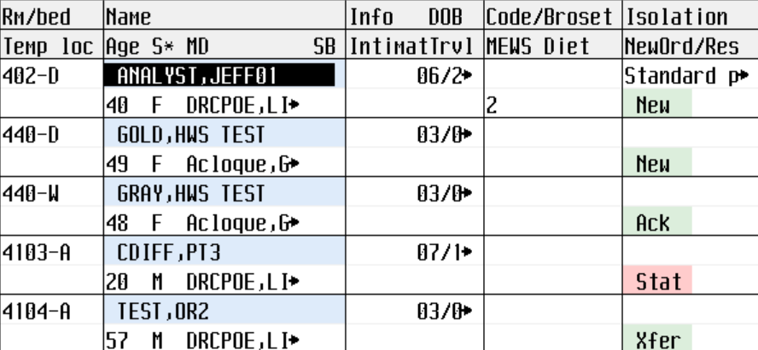

Orders that are acknowledged will flag ‘NEW’ for subsequent nurses.

**How to acknowledge new orders:**

1. Click Ack flag in Status Board.
2. **Screen lists all ACK and NEW orders.**
3. Place checkmark on all orders that need acknowledgement. Review order info below.
4. Click Acknowledge button and F12 to start acknowledging orders. Order Info can also be viewed from this screen (page up/down if needed).