**Capturing Wound Images using GE Media Manager on iMobile phones**

1. Access the Media Manager application on your iMobile phone, then log in
2. 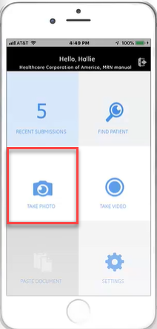Select *Take Photo* from the tile options
3. Identify the patient by scanning the patient armband and approving the associated identifying information
4. Take the photo
5. *Use photo* or *Retake* the image if needed.
6. To document image identifiers, select the image with yellow pencil
7. Identify the correct care group for phone documentation (select one)
8. Skin/Wound
9. 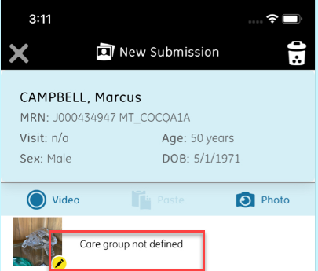Burn
10. Complex Incision
11. Complex Ostomy
12. Identify
13. Location
14. Body Part
15. Present on Admission (mandatory field for wound care group)
16. Confidentiality and Practice setting fields are set by default. No action needed.
17. Confirm documentation by selecting the blue check mark in the lower right corner
18. Select the back arrow (upper left corner) to return to the patient information with completed documentation
19. 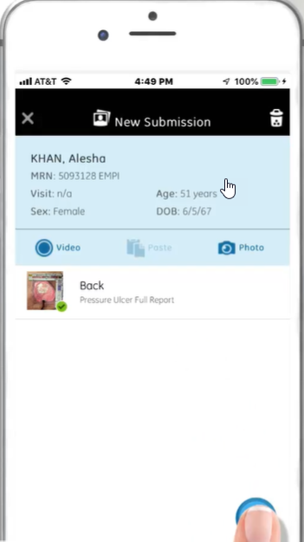If all documentation is complete, select submit by pressing the blue checkmark
20. Complete assessment documentation takes place within appropriate section of Meditech

Educational videos here: <https://mediaconnect.app.medcity.net/#/playlist/9d712554-8c14-4fa4-8458-d75c4ccc6835/videos/?videoId=49d9b7b8-bdc7-421c-8342-c71cc8468ade>



**Viewing Wound Images using**

**Zero Footprint Viewer (ZFP)**

1. 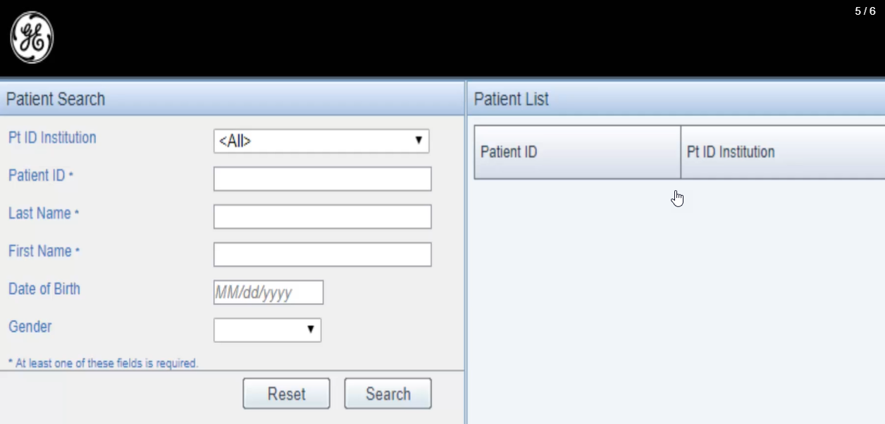Access the ZFP Viewer URL from the desktop link
2. Search for patient using identifiers
3. Images will be available on the timeline to the left of the screen in reverse chronological order.
4. Click on an image to bring it to the central area for viewing
5. Use the toolbar at the top to zoom
6. Review identifying image information collected on the phone at the time of image capture.

