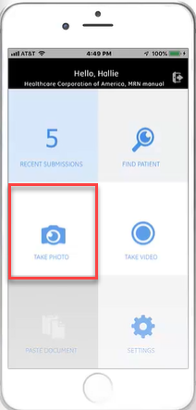

**Benefits of Wound Image Capture:**

  Improved workflow efficiency

  Easily photograph wounds without searching for a camera

  Easily view wound images from the ZFP link

  Increased wound image capture process satisfaction

 **Workflow process:**

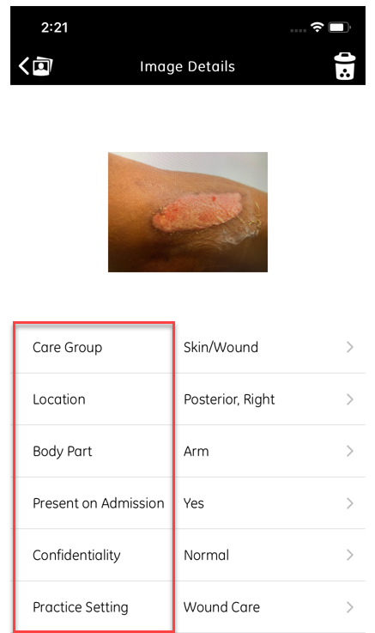

**Important dates to know:**

Kickoff - <->

  Education - <->

  Go-Live - <->

**Quotes from your colleagues:**

“Having it on iMobile is a game-changer!”

  “It is 4th of July! It’s amazing!

  “This application saves a lot of time and work!”

[**Education video**](https://mediaconnect.app.medcity.net/#/playlist/9d712554-8c14-4fa4-8458-d75c4ccc6835/videos/?videoId=49d9b7b8-bdc7-421c-8342-c71cc8468ade)