

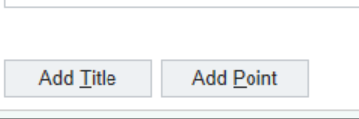

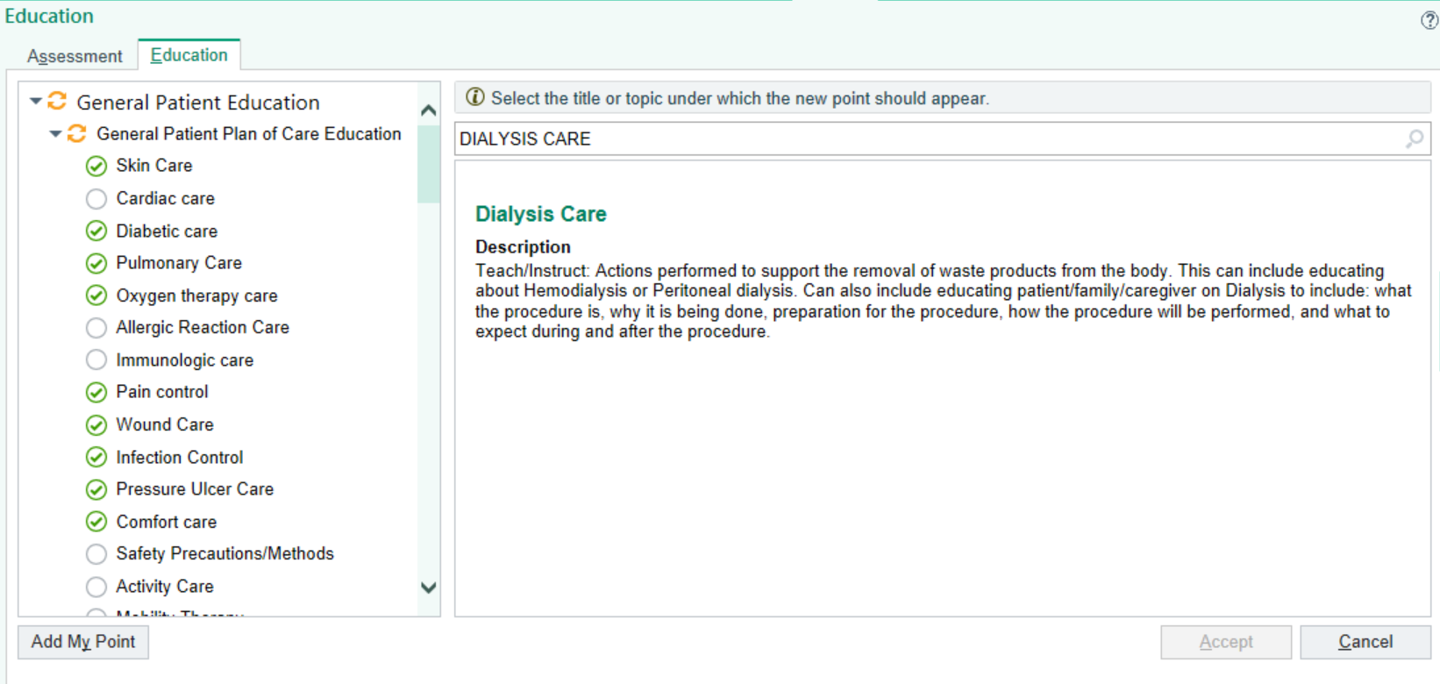

Select the section you want the point to populate under, then click accept

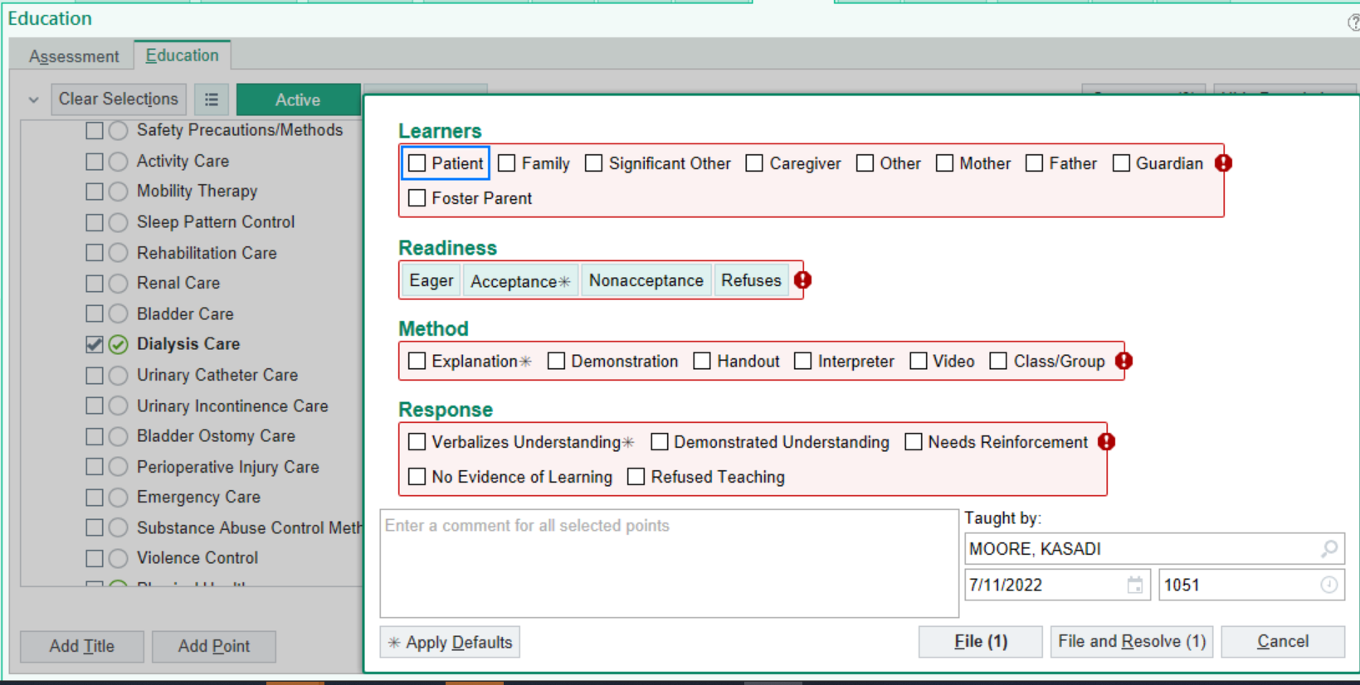

Once it has been added you can select dialysis care and document education.